- RANDOM VARIABLE

- DISCRETE RANDOM VARIABLE
- CONTINUOUS RANDOM VARIABLE

- PROBABILITY FUNCTION

- PROBABILITY MASS FUNCTION

- PROBABILITY DISTRIBUTION

- CUMULATIVE DISTRIBUTION FUNCTION

- PROBABILITY DENSITY FUNCTION

Statistics is concerned with making inferences about populations and population characteristics.

Experiments are conducted with results that are subject to chance.
The testing of a number of electronic components is an example of a statistical experiment, a term that is used to describe any process by which several chance observations are generated. It is often important to allocate a numerical description to the outcome.

For example, the sample space giving a detailed description of each possible outcome when three electronic components are tested may be written

S = {NNN, NND, NDN, DNN, NDD, DND, DDN, DDD},

where N denotes non-defective and D denotes defective.

One is naturally concerned with the number of defectives that occur.

Thus, each point in the sample space will be assigned a numerical value of 0, 1, 2, or 3.

These values are, of course, random quantities determined by the outcome of the experiment.

They may be viewed as values assumed by the random variable X, the number of defective items when three electronic components are tested.

Definition :

A random variable is a function that associates a real number with each element in the sample space.

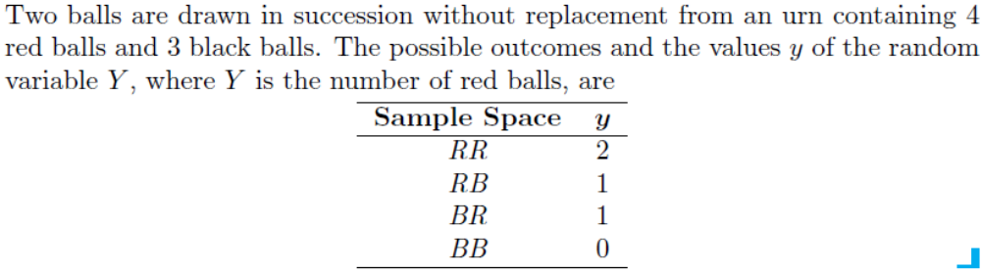
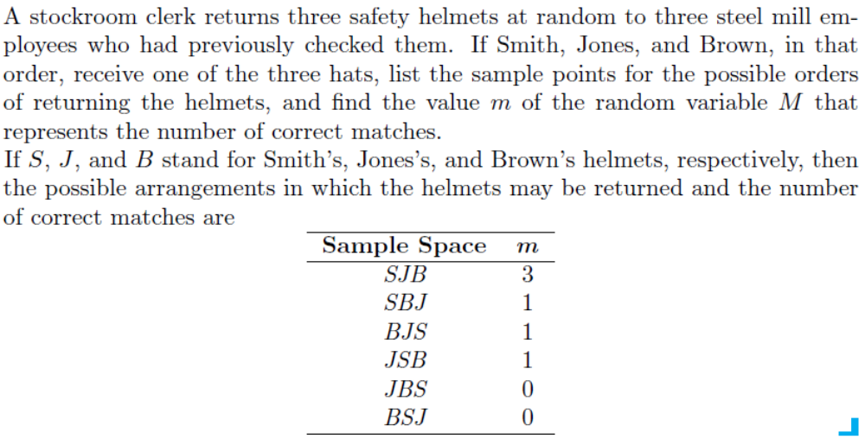

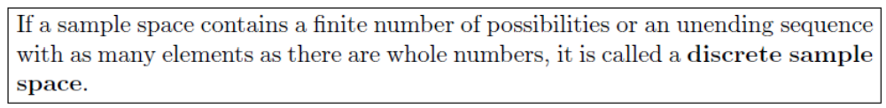

A random variable is called a discrete random variable if its set of possible outcomes is countable.

When a random variable can take on values on a continuous scale, it is called a continuous random variable.

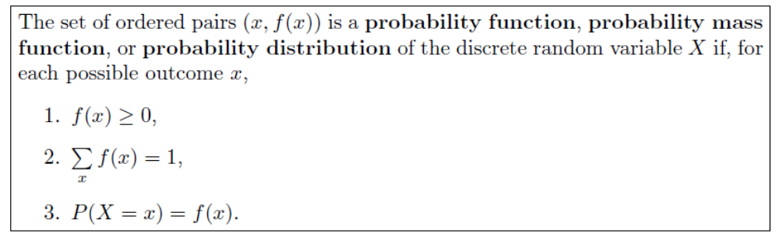

Problem: A shipment of 20 similar laptop computers to a retail outlet contains 3 that are defective. If a school makes a random purchase of 2 of these computers, find the probability distribution for the number of defectives.

Solution : Let X be a random variable whose values x are the possible numbers of defective
computers purchased by the school. Then x can only take the numbers 0, 1, and 2. Now

